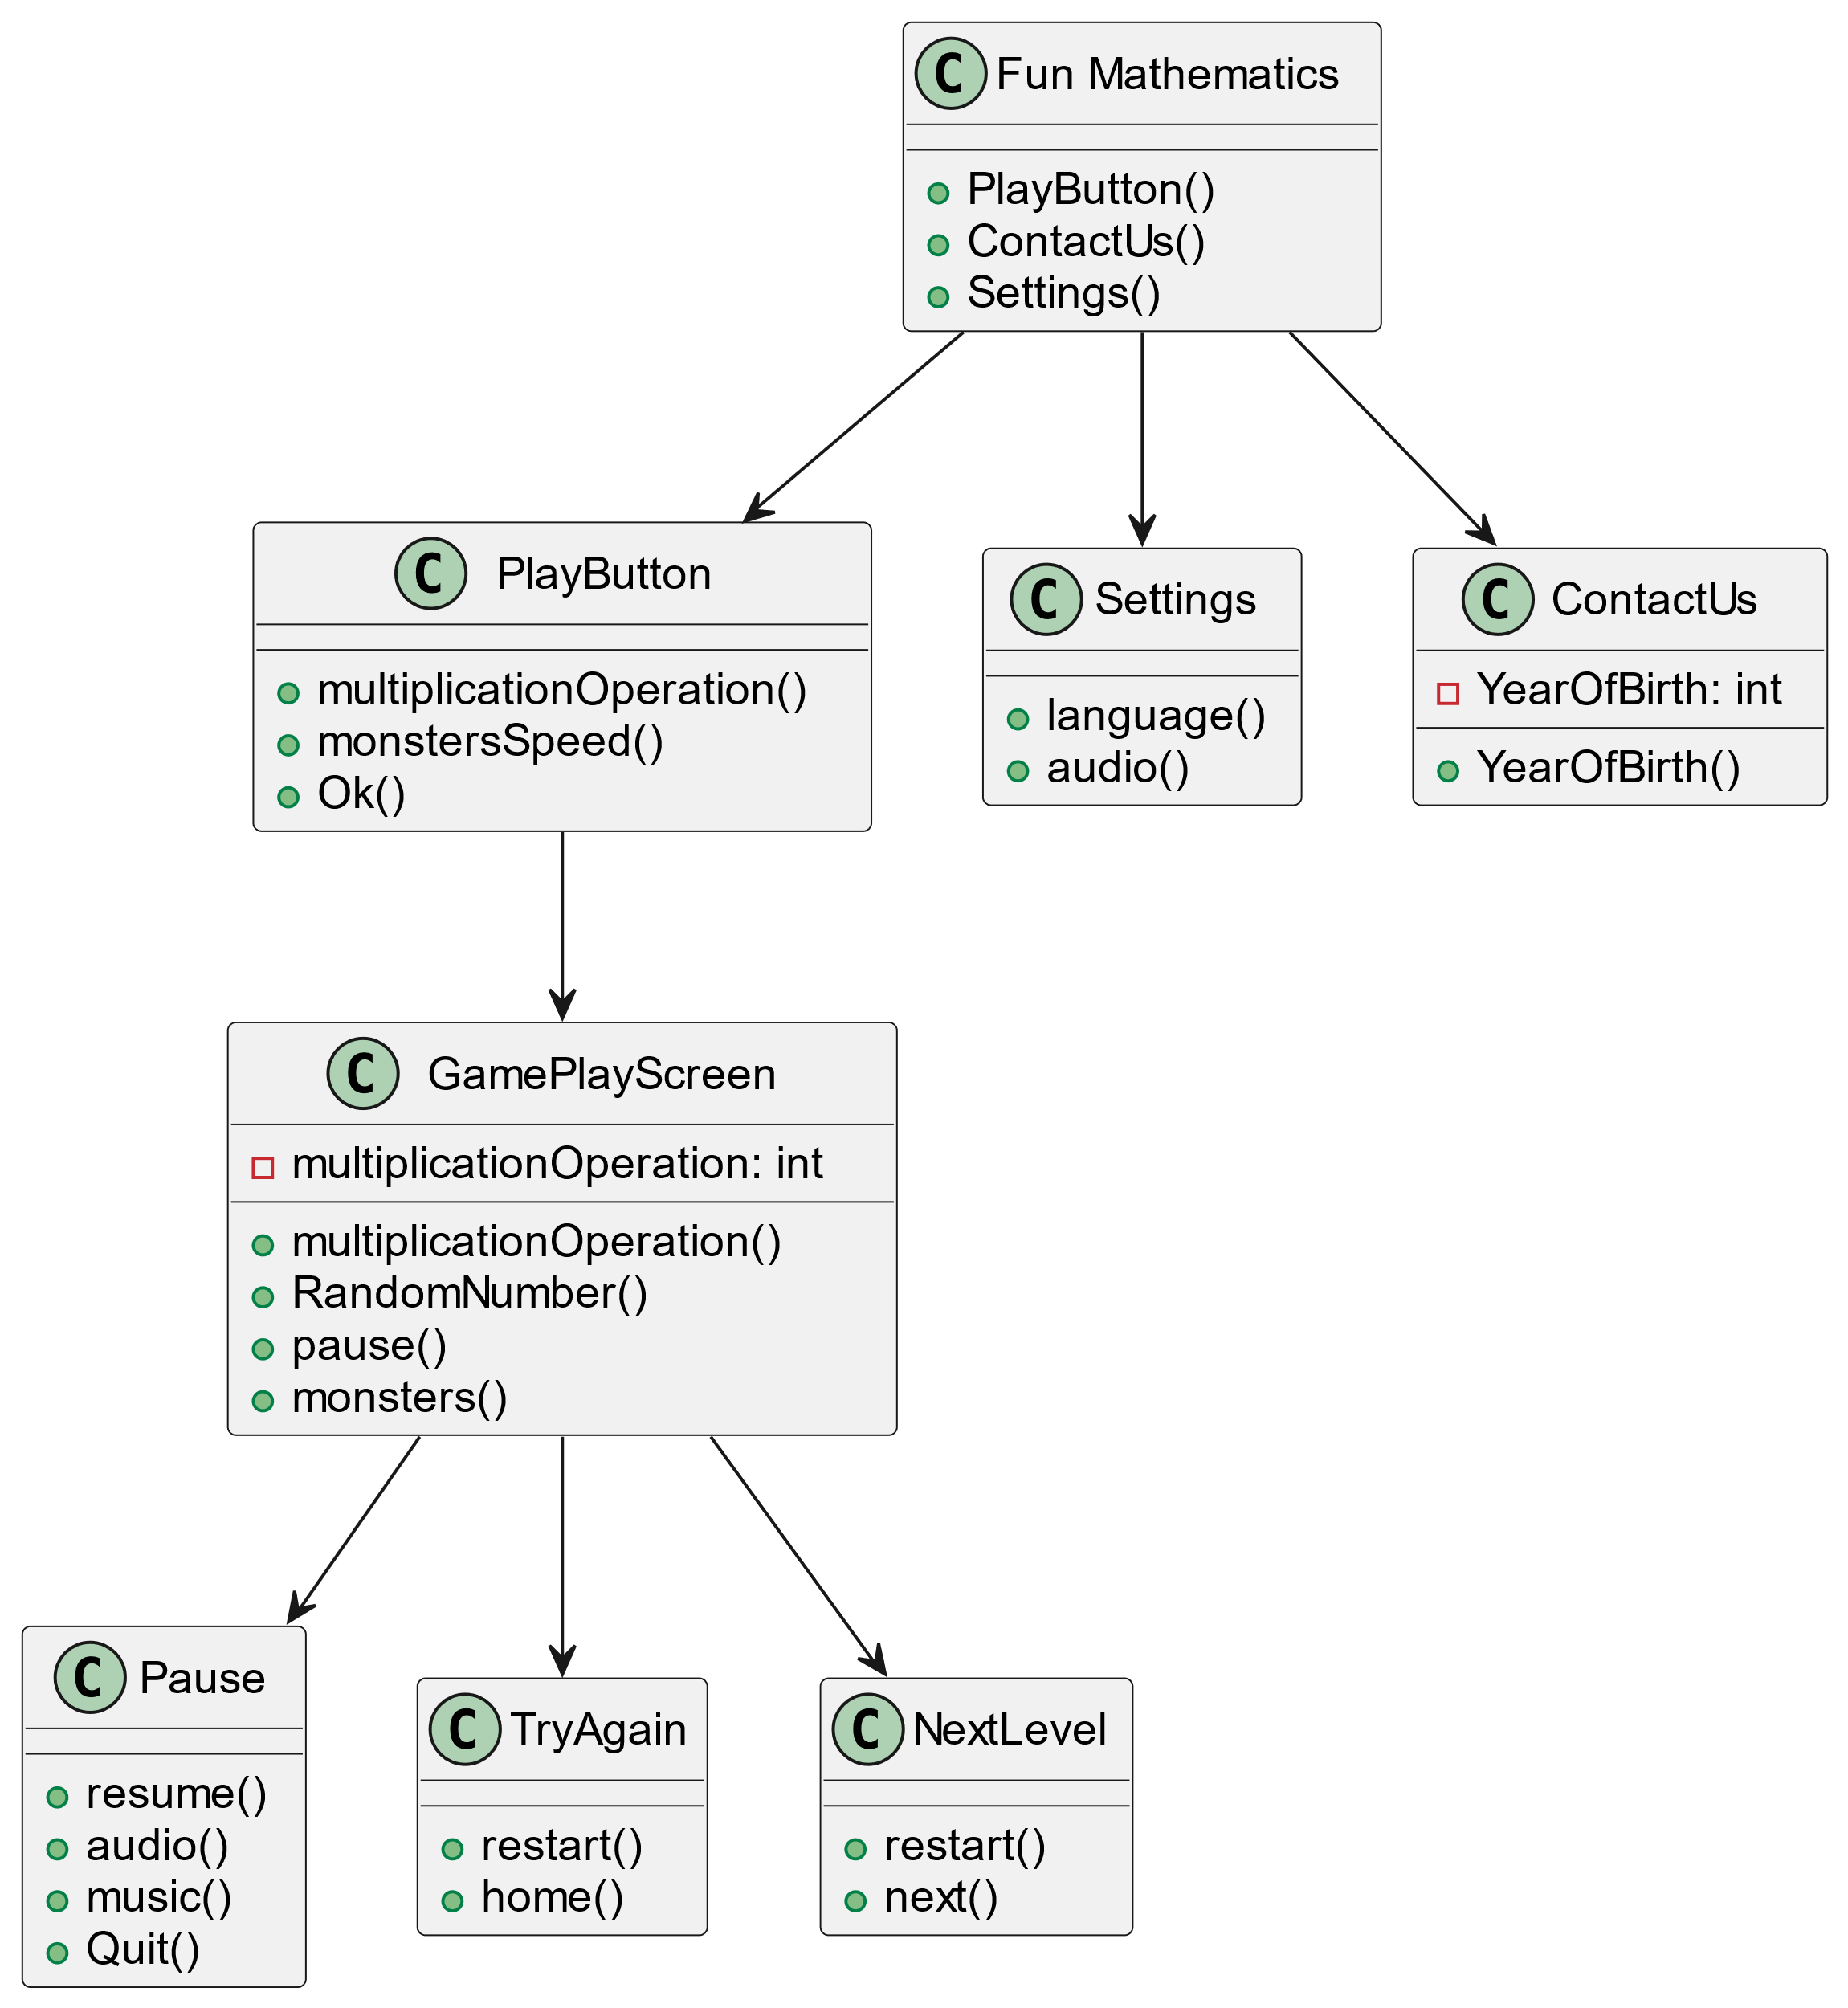

CODE:

class "Fun Mathematics" {

+ PlayButton()

+ ContactUs()

+ Settings()

}

class "PlayButton" {

+ multiplicationOperation()

+ monstersSpeed()

+Ok()

}

class "Settings" {

+ language()

+ audio()

}

class "ContactUs" {

-YearOfBirth: int

+ YearOfBirth()

}

class "Pause" {

+ resume()

+ audio()

+ music()

+ Quit()

}

class "GamePlayScreen" {

-multiplicationOperation: int

+ multiplicationOperation()

+RandomNumber()

+ pause()

+ monsters()

}

class "TryAgain" {

+ restart()

+ home()

}

class "NextLevel" {

+ restart()

+ next()

}

"Fun Mathematics" --> "PlayButton"

"Fun Mathematics" --> "ContactUs"

"Fun Mathematics" --> "Settings"

"GamePlayScreen" --> "Pause"

"PlayButton" --> "GamePlayScreen"

"GamePlayScreen" --> "TryAgain"

"GamePlayScreen" --> "NextLevel"